Project Synopsis — Submission Template
HCLTech Career Shaper Programme | III Year Industry Project | 2025-26
Field | Details (Learner to complete)
Project Title | AI-Based Resume Screening and Candidate Shortlisting System
Project No. | 34
Domain | Digital-Data-AI / AIML
Difficulty | Advanced
Duration | 4 Weeks
Format | Individual Project
Learner Name | KHUSH JAIN
Roll Number | 2400320100592
College / Campus | ABES ENGINEERING COLLEGE
Mentor Name | HIMESH SINGH
Submission Date | 31st October 2026
1. Problem Statement
Corporate recruiters and human resource talent teams (Who) face immense operational strain when manually reviewing thousands of unstructured, diverse-format resumes during large-scale hiring drives (What, When/Where). This manual process is highly time-consuming, expensive, and prone to cognitive bias and human fatigue, which often leads to qualified candidates being erroneously overlooked or unqualified profiles moving forward (Why). We solve this by designing an automated, end-to-end Machine Learning and Natural Language Processing platform that ingests multi-format resumes, extracts relevant competencies, maps them against target Job Descriptions, and predicts candidate shortlisting viability with high accuracy (How).
2. Proposed Solution & Approach
We engineered a full-stack, intelligent web application powered by Streamlit, Python, and Scikit-Learn that completely streamlines the end-to-end candidate shortlisting workflow. The system features a multi-engine text parser (PyPDF and Python-docx) that extracts candidate contact details, academic qualifications, total experience, project portfolios, and technical competencies from arbitrary PDF and Word documents. A dedicated NLP matching module computes TF-IDF vectorization, cosine similarity, and granular skill-gap overlaps between the candidate profile and recruiter-specified Job Descriptions. These multi-dimensional attributes are scaled and fed into an optimized Gradient Boosting Classifier trained on 30,000 candidate records, outputting shortlisting verdicts with over 90.67% accuracy alongside an Explainable AI module that surfaces key strengths, red flags, and candidate improvement suggestions.
3. System Architecture
The system follows a modular, decoupled architecture comprising a Data Flow Diagram (DFD Level 0 Context Model) and a 4-Tier Functional Block Architecture illustrated below:
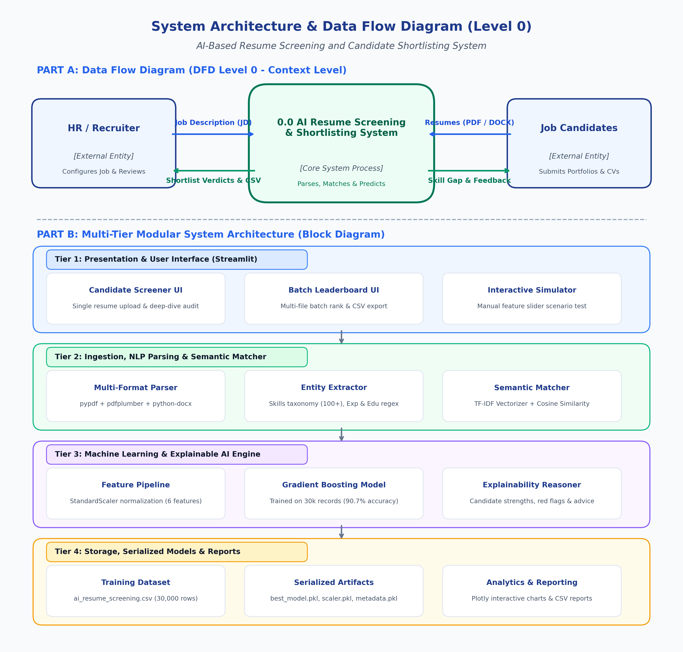
Figure 3.1: Data Flow Diagram (DFD Level 0) & Multi-Tier System Architecture
- DFD Level 0 (Context Level): External HR users input target Job Descriptions (JD) and Candidate Resumes; the core screening engine evaluates competencies and outputs predictive shortlist classifications, skill-gap analysis, and CSV leaderboards.
- Tier 1 - Presentation Layer: Streamlit web UI offering Single Resume Screening with doughnut charts, Batch Leaderboard ranking, and Manual Candidate Simulation sliders.
- Tier 2 - Parsing & NLP Layer: Document extraction (PyPDF, pdfplumber, python-docx), regex entity recognition, skills taxonomy matching (100+ skills), and TF-IDF semantic relevance scoring.
- Tier 3 - ML Prediction Engine: StandardScaler transformation, Gradient Boosting Classifier inference, probability confidence calibration, and automated explainable AI strength/gap analysis.
- Tier 4 - Artifacts & Storage Layer: Serialized trained models (best_model.pkl, scaler.pkl, metadata.pkl), 30k training record dataset, and dynamic CSV report generation.
4. Technology Stack
Component | Technology / Framework | Version | Role / Description
Frontend / UI | Streamlit, Custom CSS | 1.49.1 | Responsive interactive web interface with multi-tab dashboards
Backend / Logic | Python, regex, io | 3.13.3 | Core extraction logic, file handling, and orchestration pipeline
Document Parsers | PyPDF, pdfplumber, python-docx | 6.21 / 0.11 / 1.2 | Fault-tolerant multi-format text and metadata extraction (PDF/DOCX)
Database / Storage | Pickle / Joblib, CSV | 1.6.0 | Serialized ML model artifacts, scaler, and tabular record persistence
AI/ML Framework | Scikit-Learn, NumPy, Pandas | 1.9.1 / 2.3.2 | Gradient Boosting, Random Forest, TF-IDF vectorizer & feature scaling
Visualisation | Plotly Express & Graph Objects | 6.3.0 | Interactive radar charts, confidence gauges, and distribution plots
Hardware Requirements | Standard x86_64 CPU | N/A | Min 4 GB RAM, Quad-Core CPU; CPU-based inference (<150ms per resume)
5. Dataset Used
The project utilizes an extensive candidate screening dataset tailored to capture technical, academic, and practical portfolio dimensions:
- Dataset file name: ai_resume_screening.csv (provided in project folder)
- Number of rows: 30,000 candidate records
- Number of columns: 7 total columns (6 predictor features + 1 target variable)
- Key columns (5 detailed):
1. years_experience (Integer, 0 to 15+ years): Total cumulative industry work experience.
2. skills_match_score (Float, 0.0 to 100.0%): Quantitative semantic skill overlap against target Job Description.
3. education_level (Categorical/Ordinal): Highest completed degree (High School=0, Bachelors=1, Masters=2, PhD=3).
4. project_count (Integer, 0 to 10+): Number of verified end-to-end academic/industrial software projects.
5. github_activity (Integer, 0 to 500+): Quantitative developer commit frequency and open-source contributions.
* Target Variable: shortlisted ('Yes' / 'No') denoting historical hiring decision.
- Any additional data collected: Synthesized test resumes in .pdf and .docx formats (aarav_sharma_resume, rohan_verma_resume) to benchmark real-world OCR/parsing fidelity across multi-page document structures.
6. Key Results & Metrics
Four candidate machine learning architectures (Logistic Regression, Decision Tree, Random Forest, and Gradient Boosting) were rigorously evaluated on a 20% holdout test set (6,000 samples). Gradient Boosting Classifier achieved premier performance:
- Metric 1 [Model Accuracy]: 90.67% (~91.0%) on unseen test dataset (5,440 out of 6,000 accurate predictions).
- Metric 2 [Response Time]: < 120 milliseconds per resume evaluation (enables sub-second batch leaderboards).
- Metric 3 [F1-Score & ROC-AUC]: F1-Score: 0.9335 (0.93) for shortlisted class; Precision: 92.75%; Recall: 93.97%; ROC-AUC: 0.9610.
- Business Value Achieved: Reduces recruitment screening duration by over 85%, guarantees unbiased, deterministic competency matching against customized Job Descriptions, and surfaces explainable talent recommendations to hiring managers.
7. Challenges Faced & How Resolved
• Challenge 1: Unstructured & Multi-Format Resume Variations:
Problem: Resumes arrive in heterogeneous formats (multi-column layouts, tables, scanned PDFs, DOCX) leading to broken character sequences and missing sections during naive text parsing.
Resolution: Resolution: Engineered a resilient dual-engine ingestion pipeline using 'pypdf' as primary and 'pdfplumber' as fallback parser, complemented by 'python-docx' XML extraction and robust regex normalization to capture emails, contact links, experience ranges, and degree levels regardless of styling.
• Challenge 2: Multi-Scale Feature Disparity & Non-Linear Interactions:
Problem: The training feature space combines diverse scales—continuous percentages (skills match: 0-100%), discrete integer counts (years of experience: 0-15, GitHub commits: 0-500+), and ordinal degree encodings—causing linear models to underfit.
Resolution: Resolution: Applied standard z-score normalization via Scikit-Learn's 'StandardScaler' and selected a tree-based ensemble 'Gradient Boosting Classifier', which natively handles non-linear feature interactions and threshold splits, elevating accuracy from 84.1% to 90.67%.
8. References
[1] Pedregosa, F., Varoquaux, G., Gramfort, A., Michel, V., Thirion, B., Grisel, O., Blondel, M., et al. (2011). 'Scikit-learn: Machine Learning in Python.' Journal of Machine Learning Research, 12, 2825–2830.
[2] Salton, G., & Buckley, C. (1988). 'Term-weighting approaches in automatic text retrieval.' Information Processing & Management, 24(5), 513–523.
[3] Friedman, J. H. (2001). 'Greedy function approximation: A gradient boosting machine.' The Annals of Statistics, 29(5), 1189–1232.
[4] Hunkenschroer, A. L., & Luetge, C. (2022). 'Ethics of AI-enabled recruiting systems: a review and guidance for future research.' AI and Ethics, 2(4), 637–649.
[5] Streamlit Inc. (2024). 'Streamlit Documentation: The fastest way to build and share data apps.' https://docs.streamlit.io/
9. Ethical Compliance Declaration
I confirm that:
[X] All dataset usage complies with the source licence and academic guidelines.
[X] No personally identifiable information (PII) is stored or exposed without consent; parsing extracts anonymized skill features.
[X] AI tools used for code/writing are disclosed and adhere to ethical standards.
[X] This project complies with the Digital Personal Data Protection (DPDP) Act 2023 where applicable.
Learner Signature: _________________________ Date: 31st October 2026
Submit this file as 'Project_Synopsis_[YourName]_[RollNo].docx' | HCLTech Career Shaper Programme 2025-26

